

**YEAR: 10**

**2018**

**SUBJECT: Science**

**TEST: Forensic science**

**TIME: 50 minutes**

**QUESTIONS: 15 Multiple Choice (15 marks)**

**5 Short Answer (17 marks)**

**3 Case Study (8 marks)**

**TOTAL MARKS: 40 marks**

**DO NOT WRITE ON OR MARK THIS PAPER**

**SECTION ONE—MULTIPLE CHOICE (15 marks)**

This section has **10** questions. Answer **all** questions on the separate Multiple-choice Answer Sheet provided.

1. The term “forensic science” means

1. The science of criminology
2. The science to commit a crime
3. The science used in law courts
4. The scientists that are criminals

2. To be a good eyewitness, a person should be:

1. Tired and angry
2. Alert and observant
3. Alert and angry
4. Tired and observant

3. Small items of evidence left at crime scenes are:

1. Touch traces
2. Contact touches
3. Clothes contacts
4. Contact traces

4. Major crimes that come to court are mainly placed in front of a:

1. judge
2. jury
3. magistrate
4. lawyer

5. Ballistics is the study of:

1. ball bearings
2. bailiffs
3. guns
4. guns and bullets.

6. The Lockard Exchange Principle says that

1. every contact leaves a trace
2. evidence can always be found
3. evidence found at crime scenes always lead to prosecution
4. criminals always makes mistakes

7. The microscope used by forensic laboratories is the _____________ microscope.

1. electron
2. compound
3. comparison
4. stereoscopic

8. Which of the fibres below are natural?

1. linen
2. rayon
3. nylon
4. polyester

9. The instrument used to study fibres in detail is:

1. Spectroscope
2. Telescope
3. Microscope
4. Stethoscope

10. The most common type of fingerprint pattern is:

1. arch
2. loop
3. whorl
4. delta

11. Under a microscope, a hair sample with a smooth and regular surface, it is likely to be;

1. human hair
2. horse hair
3. synthetic hair
4. wool

12. Blood is a complex mixture of four main components. Red blood cells, white blood cells, platelets and _________________?

1. syrup
2. oxygen
3. water
4. plasma

13. Apart from fingerprints what other evidence could help identify a body?

1. DNA
2. clothing
3. jewellery
4. hair

14. The most common blood type of people in the U.K., U.S.A. and Australia is?

1. A
2. B
3. O
4. AB

15. Name the substance that is not produced by sweat glands:

1. water
2. amino acids
3. salts
4. oil



**SEMESTER ONE 2016**

**Forensic science Test:**

**ANSWER BOOKLET**

**NAME:**

**FORM:** **DATE:**

Multiple Choice Short Answer Total

**/35**

**/17**

**/15**

**SECTION ONE:** Multiple choice answers

Cross (X) through the correct answer.

|  |  |  |  |  |
| --- | --- | --- | --- | --- |
| **1** | a | b | c | d |
| **2** | a | b | c | d |
| **3** | a | b | c | d |
| **4** | a | b | c | d |
| **5** | a | b | c | d |
| **6** | a | b | c | d |
| **7** | a | b | c | d |
| **8** | a | b | c | d |
| **9** | a | b | c | d |
| **10** | a | b | c | d |
| **11** | a | b | c | d |
| **12** | a | b | c | d |
| **13** | a | b | c | d |
| **14** | a | b | c | d |
| **15** | a | b | c | d |

**SECTION TWO: Short Answer (17 marks)**

Answer the questions in the spaces provided.

1. Look at the prints below. **Circle** the print which best matches the one found at the crime scene. (1 mark)

\\e4128s01sv001.green.schools.internal\temp$\staff\201809181514-1.tif

**2.**

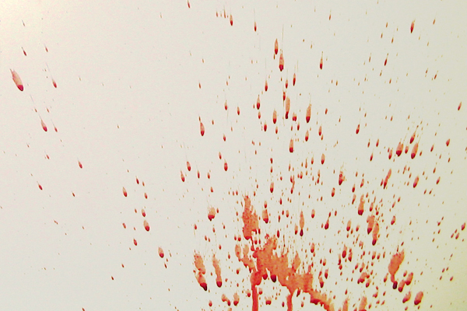

2a) What blood spatter pattern can be seen above? (1 mark)

Medium velocity spatter

b) What can we conclude from this pattern? (2 marks)

-Indicated blunt/sharp trauma or cast off.   
-Victim was hit by a weapon

3. Look at the (fake) crime scene below. Circle the three differences in the second picture.

(3 marks)

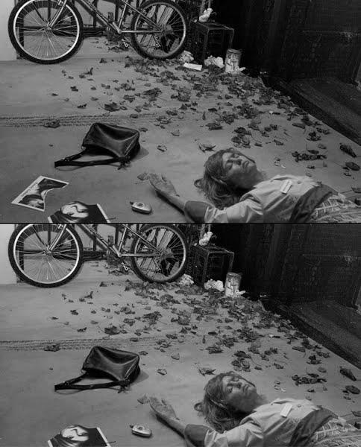



4. Describe 4 things must be done at a crime scene.

(2 marks)

-Interview witnesses/first responders  
-Secure crime scene

-Document crime scene (photos, sketches etc)

-Examine/Process/Collect evidence

**5.List** the two types of fibres. Describe the **differences** between them along with **examples**.

Types of fibres: Synthetic (1) and natural fibres(1)

Differences: Synthetic: man-made (1), Smooth and have much longer length (1) (staple)

Natural: made from either plants or from animals (1) Rougher surface taper from root to tip and appear somewhat irregular (1)

Examples: Synthetic: rayon, terylene, polyester, nylon (1)

Natural: cotton, linen, wool, silk, mohair (1)

**Section THREE: Case Study**

Read the following article and answer the questions below:

\\e4128s01sv001.green.schools.internal\temp$\staff\201809181514.tif

6. List the trace evidence found with the boy’s body. (1 mark)

Dog and human hair, pollen

7. Did all the evidence prove the suspect’s guilt? Explain your answer. (2 marks)

-No-it didn’t prove it.   
-The evidence strongly suggested he did it.

8. What evidence found in this 1960 crime could be better analysed today? Describe how this evidence would have been processed and what it could have shown us. (5 marks)

-Fingerprints

-Could have found on rug/body  
-Used chemicals to develop prints

-It could have shown if the suspect touched the rug/body  
-Provide more evidence they committed the crime

**END OF TEST**

Please check your work!